**nocLock Test Plan**

**T02-Nov 11th, 2014**

Travis Berger, Cameron Tribe, Jaime Rodriguez, Sean Koppenhafer

|  |  |  |  |
| --- | --- | --- | --- |
| Revision | Author(s) | Date | Summary |
| 1.0 | Travis | 11/20 | First Draft of Doucment |
|  |  |  |  |

Table of Contents

Project Requirements3

Block Diagram4

Test Equipment5

Personnel Qualifications6

Test Categories7

Unit Module7

Integration Test8

Parametric Test8

Function Testing9

Use Testing10

Error Testing.11

Reliability Testing.12

PROJECT REQUIREMENTS

|  |  |  |
| --- | --- | --- |
| **Marketing Requirements** | **Engineering Requirements** | **Justification** |
| 1,2,3 | Must be able to read and store a knock sequence. Must be able to lock and unlock if user enters stored knock sequence. | These requirements establish the basic functionality of the device. |
| 2 | Must be able to store up to 100 knocks in a sequence. Must be able to differentiate between different knock sequences. | These performance requirements establish a maximum number of knocks that can be recorded in a knock sequence. |
| 3 | Should be able to restore a knock sequence after losing power. | This ensures that the product will be dependable and has safeguards against failures. |
| 7 | Should not exceed $40 production costs. | This is the maximum production cost that will ensure that the product is affordable. |
| 3,7 | Must have average power consumption less than 1 Watt. | This is the minimum amount of power for device to perform properly without consuming excess amounts of power. |
| 5 | Must have packaged circuitry protected from user. | This protects user from exposed circuitry that could potentially burn or cut them. |
| 5 | Must be safe to leave on for long periods of time. | This device must be left on for long periods of time and still meet safety requirements. |
| 5 | Must be made from non-toxic materials. | This device must be made with materials that are safe for users to operate. |
| 5,7 | Must be made with non toxic/hazardous chemicals that would require proper disposal. | Disposing of hazardous/toxic materials during fabrication would raise production costs. |
| 3,7,8 | Must have minimal user maintenance over entire life cycle. | This device must be designed to be dependable and durable throughout its life cycle. Servicing or repairs would drive the cost too high. |
| 3,8,9 | Must be reliable for complete life cycle. | Servicing is not an option so the device must be designed to be reliable for over its entire life cycle. |
| 4,9 | Must be easy for user to learn how to operate device. | If the device is overly complex and hard for the user to operate no one will want to use the device. |
| 3,4,9 | Must work the same every time user uses device. | The device must work the way it is expected to work every time it is used. If the device acts erratically it will be rendered useless and not dependable. |
| 4,9 | Must have some form of instructions for the user. | The user needs a way to learn how to operate the device. |
| **Marketing Requirements**   1. Device must lock and unlock. 2. Device must differentiate between many distinct knock sequences 3. Device must be dependable. 4. Device should be user friendly. 5. Device must be safe. 6. Device should have a desirable professional look. 7. Device must be affordable. 8. Device must be durable. 9. Device cannot require service. | | |

BLOCK DIAGRAM OF BASIC SCHEMATIC

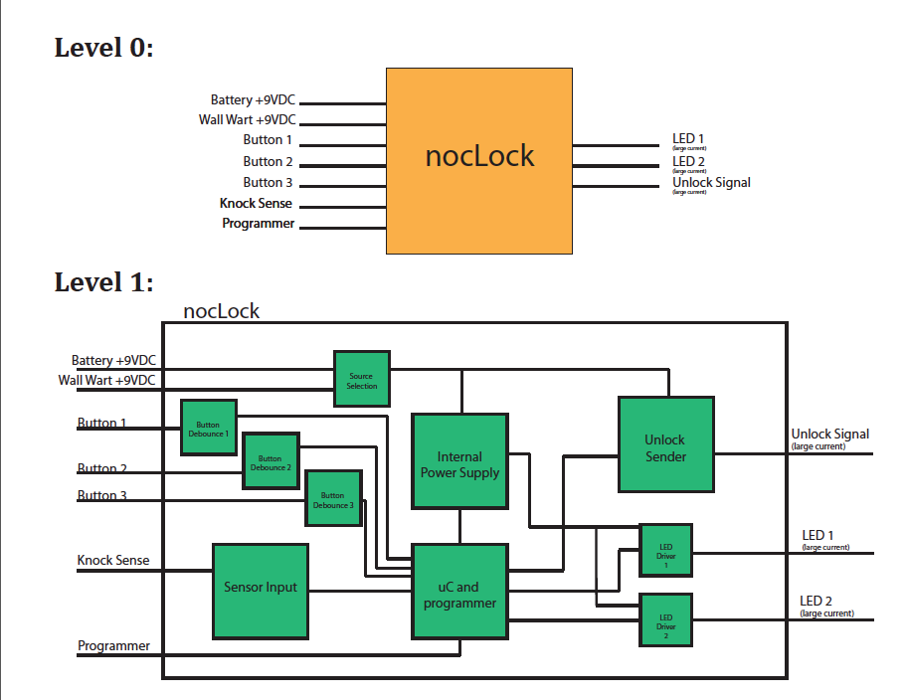

Test Equipment

1. Oscilloscope
2. Digital Multi-meter
3. Function Generator
4. Two Channel DC Power Supply
5. AVR Dragon Board*

* AVR Dragon Boards are limited in supply. Any tests that require an AVR Dragon Board need to be scheduled with enough time to meet the deadline with limited availability.

Personnel Qualifications

**Level 1 Operator:** Ability to use test equipment to perform tests. Needs all equipment setup or requires precise setup documentation. Cannot use AVR Dragon Board.

**Level 2 Technician:** Ability to setup and use test equipment to perform tests. Can load software using AVR Dragon Board but cannot make changes to software.

**Level 3 Engineer:** Ability to setup and use test equipment to perform tests. Has ability to modify or change software and use AVR Dragon Board to actively debug microcontroller. Can make changes to test plan and test cases with approval from Test Plan authors.

Test Categories

1. Unit/Module Test

Summary: During this phase of testing each listed module will be tested independent of any other module. For each Unit/Module Test the required test equipment and personnel qualifications will be specified. Test Case names are listed for each test. Refer to test case for test setup, summary of test, test procedure, and expected results when conducting each test.

1. Power Supply Module
   * Test Equipment: 1,2,3,4
   * Personnel Qualifications: Requires Level 2
   * Test Case 1.1
2. Solenoid Driver Module
   * Test Equipment: 1,2,3,4
   * Personnel Qualifications: Requires Level 2
   * Test Case 1.2
3. Knock Sensor Module
   * Test Equipment: 1,2,3,4
   * Personnel Qualifications: Requires Level 2
   * Test Case 1.3
4. LED Drive Module
   * Test Equipment: 1,2,3,4
   * Personnel Qualifications: Requires Level 2
   * Test Case 1.4
5. Button Modules
   * Test Equipment: 1,2,3,4
   * Personnel Qualifications: Requires Level 2
   * Test Case 1.5
6. ICSP Module
   * Test Equipment: 1,2,3,4,5
   * Personnel Qualifications: Requires Level 3
   * Test Case 1.6
7. Microcontroller Module
   * Test Equipment: 1,2,3,4,5
   * Personnel Qualifications: Requires Level 3
   * Test Case 1.7
8. Integration Test

Summary: During this phase of testing certain modules will be integrated together and tested to determine performance. For each Test the required test equipment and personnel qualifications will be specified. For best results tests should be performed in the order below. Test Case names are listed for each test. Refer to test case for test setup, summary of test, test procedures and expected results when conducting each test.

1. Integrate Power Supply with Microcontroller
   * Test Equipment: 1,2,3,4,5
   * Personnel Qualifications: Requires Level 2
   * Test Case: 2.1
2. Integrate Solenoid Drive with Microcontroller
   * Test Equipment: 1,2,3,4,5
   * Personnel Qualifications: Requires Level 2
   * Test Case 2.2
3. Integrate Microcontroller, Knock Sensor, Solenoid Driver
   * Test Equipment: 1,2,3,4,5
   * Personnel Qualifications: Requires Level 2
   * Test Case 2.3
4. Integrate Microcontroller, Knock Sensor, Solenoid Driver, Button Modules
   * Test Equipment: 1,2,3,4,5
   * Personnel Qualifications: Requires Level 2
   * Test Case 2.4
5. Integrate Microcontroller, Knock Sensor, Solenoid Driver, Button Modules, LED Drive
   * Test Equipment: 1,2,3,4,5
   * Personnel Qualifications: Requires Level 2
   * Test Case 2.5
6. Parametric Test

Summary: During this test phase each test is done using black box testing to measure key performance parameters. This is the fastest way to test the device and the best way to perform manufacturing testing. For clarity, tests are broken up into their individual modules listing needed test equipment, personnel qualifications and test case. Refer to test case for test setup, summary of test, test procedures and expected results for conducting each test.

1. Power Supply
   * Test Equipment: 1,2,3,4
   * Personnel Qualifications: Requires Level 1
   * Test Case 3.1
2. Solenoid Drive Module
   * Test Equipment: 1,2,3,4
   * Personnel Qualifications: Requires Level 1
   * Test Case 3.2
3. Knock Sensor
   * Test Equipment: 1,2,3,4
   * Personnel Qualifications: Requires Level 1
   * Test Case 3.3
4. Button Debounce
   * Test Equipment: 1,2,3,4
   * Personnel Qualifications: Requires Level 1
   * Test Case 3.4
5. Microcontroller
   * Test Equipment: 1,2,3,4,5
   * Personnel Qualifications: Requires Level 2
   * Test Case 3.5
6. Total Project Test
   * Test Equipment: 1,2,3,4,5
   * Personnel Qualifications: Requires Level 2
   * Test Case 3.6
7. Function Testing

Summary: During this test phase the operations of the nocLock are tested to validate that they are functional. For best practice while performing function tests refer to Use-Case for each operation found in the nocLock System Design Document. Refer to test case for test setup, summary of test, test procedures and expected results when conducting each test.

1. Program Knock
   * Test Equipment: 1,2,3,4,5
   * Personnel Qualifications: Requires Level 3
   * Test Case 4.1
2. Unlock Device
   * Test Equipment: 1,2,3,4,5
   * Personnel Qualifications: Requires Level 3
   * Test Case 4.2
3. Reset Device
   * Test Equipment: 1,2,3,4,5
   * Personnel Qualifications: Requires Level 3
   * Test Case 4.3
4. Use Testing

Summary: Use testing is conducted by having an outside user, who is unfamiliar with the product, use the product as it is intended. These tests are broken up by basic operation to ensure that every operation of this device is tested and useable by the end user. Refer to test case for test setup, summary of test, operation instructions, test procedures and expected results for conducting each test.

1. Program Knock
   * Test Equipment: N/A
   * Personnel Qualifications: Requires Level 1
   * Test Case 5.1
2. Unlock Device
   * Test Equipment: N/A
   * Personnel Qualifications: Requires Level 1
   * Test Case 5.2
3. Reset Device
   * Test Equipment: N/A
   * Personnel Qualifications: Requires Level 1
   * Test Case 5.3
4. Error Testing

Summary: During error testing known errors are purposely applied to the system to understand system failures and eliminate any possible bugs that can result from error failures. Refer to test case for test setup, summary of test, test procedures and expected results when conducting each test.

1. Power Supply Fault
   * Test Equipment: 1,2,3,4,
   * Personnel Qualifications: Requires Level 3
   * Test Case 6.1
2. Button Debounce Error
   * Test Equipment: 1,2,3,4
   * Personnel Qualifications: Requires Level 3
   * Test Case 6.2

1. Knock Delay Error
   * Test Equipment: 1,2,3,4
   * Personnel Qualifications: Requires Level 3
   * Test Case 6.3
2. Knocks Low Threshold Error
   * Test Equipment: 1,2,3,4
   * Personnel Qualifications: Requires Level 3
   * Test Case 6.4
3. Reliability Testing

Summary: Reliability testing tests key parts of the nocLock for reliability. Reliability is an important test criteria because one of the marketing requirements of the nocLock is to not require service.

* 1. System Reliability
     + Test Equipment:
     + Personnel Qualifications: Requires Level 2
     + Test Case 7.1
  2. EEPROM Reliability
     + Test Equipment:
     + Personnel Qualifications: Requires Level 3
     + Test Case 7.2